|  |  |
| --- | --- |
| User Manual  VisioDesk  Version 1.0  November 2014  English | Logo_VisioDesk 4C |

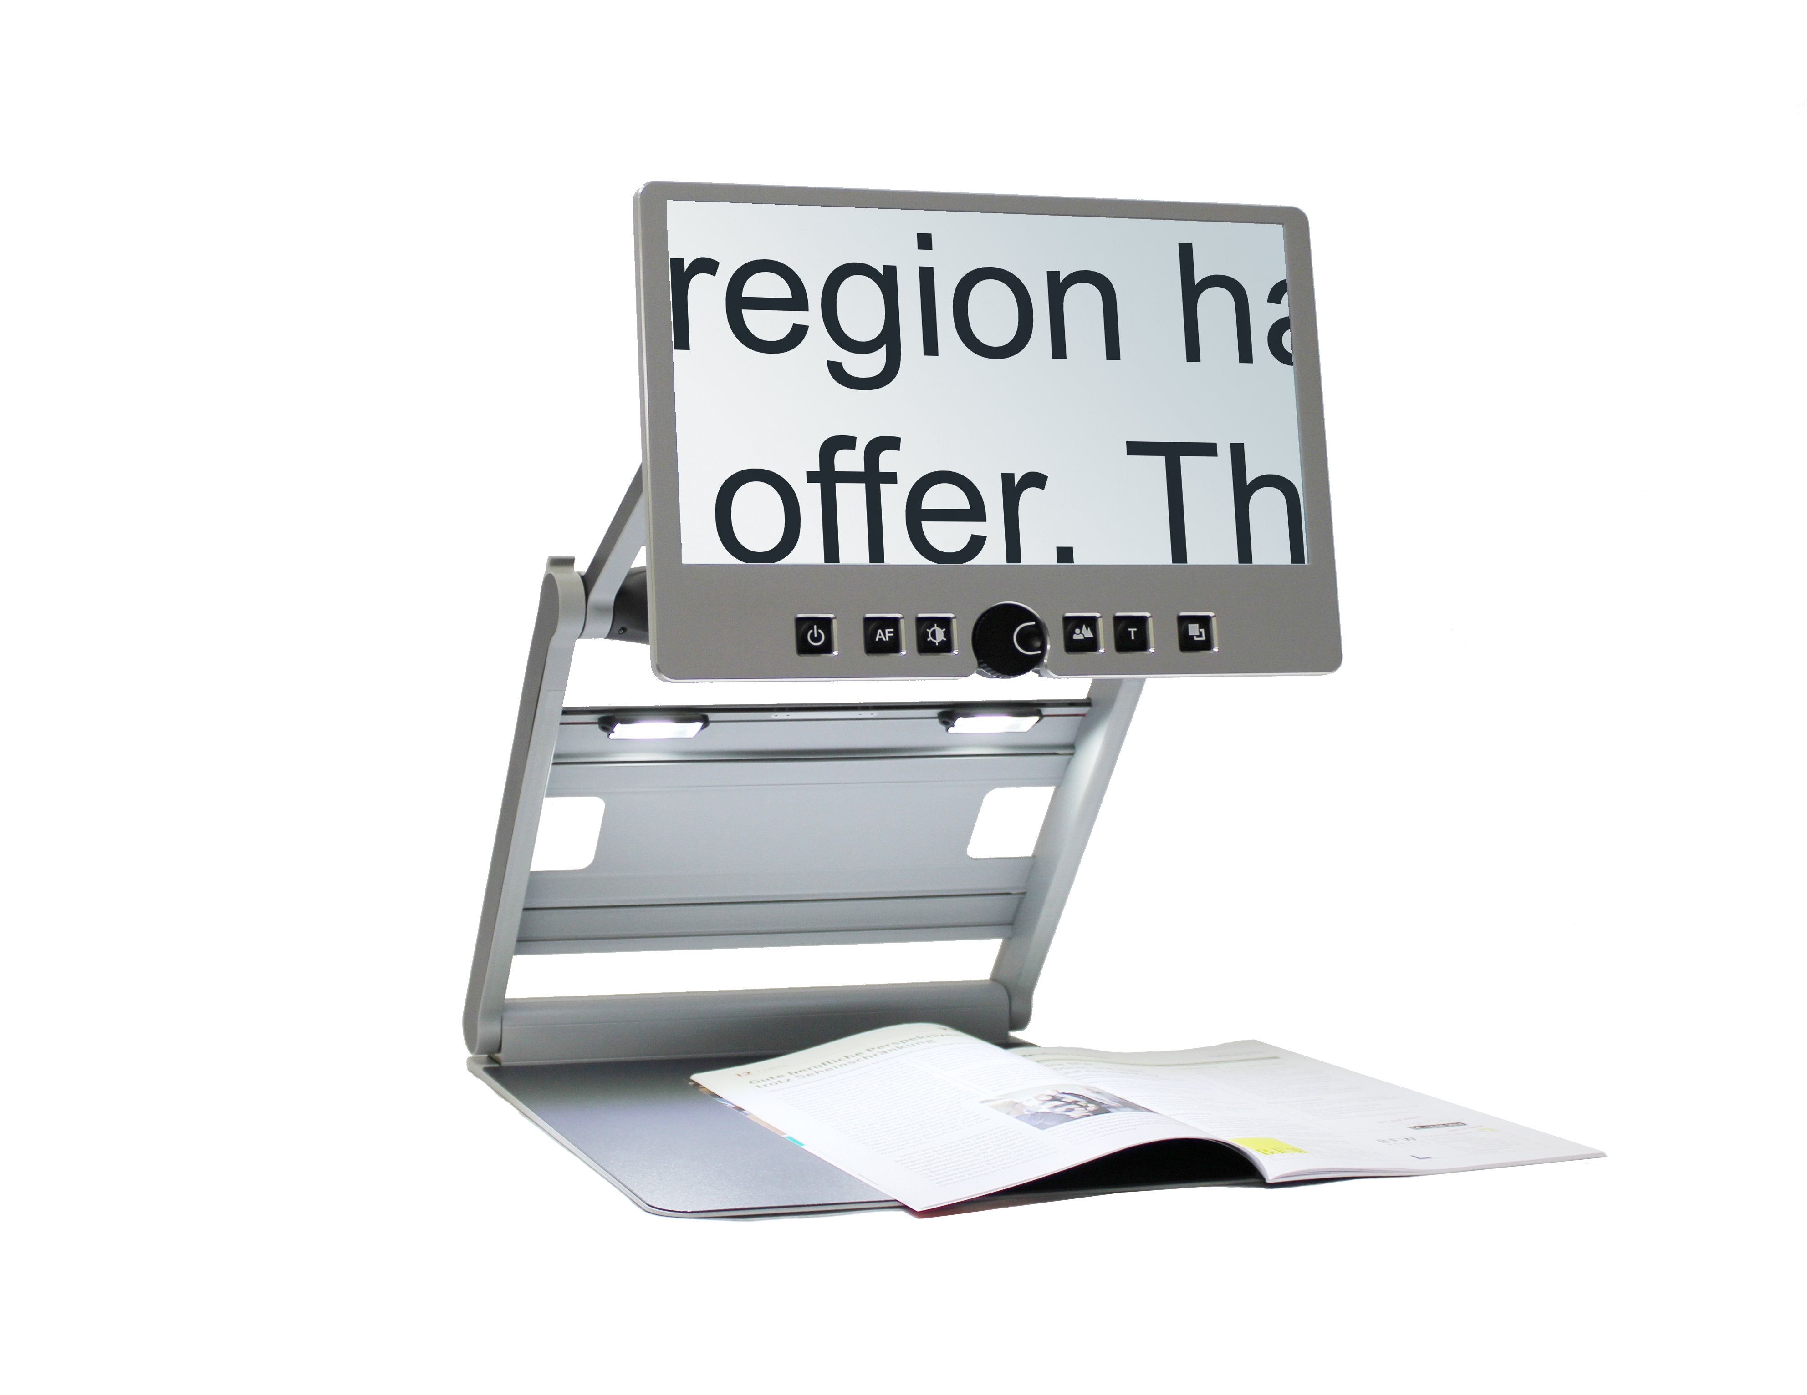



# About this manual

Thank you for purchasing a VisioDesk from BAUM Retec. The purpose of this manual is to provide the end user and/or their service provider with details on how to use VisioDesk.

VisioDesk is a high-quality, German-made portable video magnifier, which will provide you many years of reliable service. This manual contains everything you need to know to use your new device.

As you will learn, VisioDesk is very easy to use. In addition to instructions on how to operate VisioDesk, this manual also includes recommendations for how to position your device, what to do if something goes wrong, and share some important safety guidelines.

We suggest that you store this manual in a safe place for future reference.

**Notice for End Users in Germany/Europe**

This manual is a part of the VisioDesk product, and should be kept with the product at all times. In the event your VisioDesk is ever sold to a new end user, this manual must be provided to them.

**Copyright Notice**

Copyright © 2014 BAUM Retec AG, In der Au 22, Wiesenbach, Germany. All rights reserved. No part of this publication may be reproduced or distributed in any form or by any means, or stored in a database or retrieval system, without prior written permission from BAUM Retec AG.

All efforts have been made to ensure that information contained in this document is correct at the time of issue. Neither BAUM Retec AG nor its representatives assume any responsibility for errors or omissions. Nor is any liability assumed for damages resulting from the use of information contained herein.

**Licenses and trademarks**

All licenses and trademarks are the property of their respective owners.

# About VisioDesk

Beautifully designed, high quality, very portable, simple to use, yet powerful – this is the definition of VISIO. VisioBook and VisioDesk are the smallest and most flexible members of the VISIO family.

VisioDesk can be folded flat when not in use, which combined with being lightweight (10.5 lbs. / 4.8 kg) makes for an extremely portable device. Best of all, VisioDesk is battery powered, running for 6 hours before you need to recharge it.

VisioDesk features a full HD camera, a 15.6” display (16:9 format, full HD), with high contrast and power saving LED backlight. Thanks to the full HD camera VisioDesk provides a bright and crisp image even at the smallest magnification level. This is especially helpful for users with retinitis pigmentosa (RP).

Despite being one of the smallest and lightweight devices, VisioDesk provides the type of functionality you expect from a basic CCTV reader.

VisioDesk displays magnified text and images in your choice of full color, black on white, or white on black and a variety of false colors. Autofocus is provided as well as optional fix focus for hand writing and filling in forms. Thanks to its image optimizer feature VisioBook will always provide an optimum image quality, ensuring that text is always crisp and clear.

The VisioDesk camera can be pivoted in 4 four positions. So besides viewing down on a sheet of paper, you may also use the distance view or mirror positions of the camera.The display screen can be easily adjusted to the height and angle you prefer.

VisioDesk will, in most cases, take documents of poor quality (e.g. faint print, crumpled or dirty paper, etc.) and magnify them in high contrast. However, despite all of our technical efforts, there will be some documents that cannot be displayed properly. In these rare instances, the full color setting is the best setting.

# Table of contents

[About this manual 2](#_Toc403138949)

[About VisioDesk 3](#_Toc403138950)

[Table of contents 4](#_Toc403138951)

[Before you begin 5](#_Toc403138952)

[What comes in the box? 5](#_Toc403138953)

[How to position VisioDesk on your desk 6](#_Toc403138954)

[Camera positions 8](#_Toc403138955)

[Power Adaptor 9](#_Toc403138956)

[VisioDesk Control Panel 10](#_Toc403138957)

[VisioDesk Control panel buttons – quick reference 10](#_Toc403138958)

[Becoming Familiar With Your New VisioDesk 12](#_Toc403138959)

[**Switch off light** 15](#_Toc403138960)

[**Autofocus** 15](#_Toc403138961)

[**Alternative set of false colors** 16](#_Toc403138962)

[External connections of VisioDesk 16](#_Toc403138963)

[**USB Output** 16](#_Toc403138964)

[**Video output** 17](#_Toc403138965)

[**Video input** 17](#_Toc403138966)

[For your safety 17](#_Toc403138967)

[Common problems and solutions 19](#_Toc403138968)

[**Display and light remain dark** 19](#_Toc403138969)

[**Image is blurred** 20](#_Toc403138970)

[**Document cannot be read** 20](#_Toc403138971)

[**Letters are flickering** 20](#_Toc403138972)

[Environmentally friendly disposal according to EC-Directive 2002/96/EG 21](#_Toc403138973)

[Warranty 22](#_Toc403138974)

[Defects and Repair 22](#_Toc403138975)

[Service box 23](#_Toc403138976)

[Technical Specifications 24](#_Toc403138977)

[**Product description:** 25](#_Toc403138978)

[**Specific purpose:** 25](#_Toc403138979)

[**Product life time:** 25](#_Toc403138980)

[**Re-use / Installation and Maintenance:** 25](#_Toc403138981)

[**Safety checks (§6 MP-BetreibV):** 25](#_Toc403138982)

[**Special advice for transport and storage:** 26](#_Toc403138983)

[**Power cable:** 26](#_Toc403138984)

[Product Identity Sheet VisioDesk 28](#_Toc403138985)

# Before you begin

Please read the safety instructions at the end of this manual and check the contents of the packaging.

# What comes in the box?

|  |  |
| --- | --- |
| * 1 VisioDesk * 1 carrying bag * 1 Power Adaptor * 1 User Manual * 1 Cleaning cloth for camera window and display |  |

# How to position VisioDesk on your desk

|  |  |
| --- | --- |
|  | Place folded VisioDesk on the table, with the front end approximately 8 inches (20 cm) from the edge of table. |
|  | Hold down base plate with one hand while thumb of other hand grabs front corner of one of the arms. |
|  | Lift arm until you feel it snap into position.  **Warning:** To avoid touching the camera window, do not lift from the camera housing! |
|  | Now place your hands on both sides of display. |
|  | Pull display towards your body… |
|  | …while swinging it slightly upwards. |
|  | Adjust display to your preferred height and tilt. |
|  | Grab side of camera and pivot camera from transport position in downward position directing slightly to you. Camera now faces towards front edge of base. From transport position, this is the second snap in position. |

If you want to fold VisioDesk shut, proceed in reverse order. Pivot the VisioDesk camera unit to the transport position for folding. This is the second snap in position. The two rubber straps will then rest on the bottom plate when shut. VisioDesk will switch off automatically once the device is folded shut.

# Camera positions

After unfolding VisioDesk, the camera can be pivoted to 4 positions. The close-up lens will slide in automatically if required.

|  |  |  |  |
| --- | --- | --- | --- |
|  |  |  |  |

* Snap in position directing straight down on ground plate. For viewing small objects.
* The next snap in position is the normal reading position. The camera unit is tilted slightly to the front. This is for normal reading (any image distortion will automatically be corrected as the autofocus takes effect). The camera looks toward the front edge of the base. In other words, if you put a page on the base, the camera will look at the bottom of the page. Thus by moving the paper (up, down, left, right), you can read the entire page.
* Far view position to the front, camera facing away from user, for reading from a black board etc. Camera does not snap in allowing you to adjust viewing angle.
* Mirror position. Pull display down below camera and pivot camera window to front, so your face will be shown on display. This position also does not snap in.
* The third snap in position is the transport position. Camera faces down parallel to the arm. Wen folded shut, the two rubber straps on camera will rest on the base, preventing it from scratches.

|  |  |  |  |
| --- | --- | --- | --- |
|  |  |  |  |

# Power Adaptor

If you want to use VisioDesk for an extended period of time, or if you need to charge the battery, connect one end of the power adaptor into the back of your VisioDesk, and then plug the other end in to a power outlet. The power control light on VisioDesk will turn orange while charging of the battery takes place, and turn green when charging is complete.



VisioDesk can be operated while charging of the battery takes place. Charging will automatically end once the battery is full, so you can leave it connected as long as you like.

When fully charged, the battery in VisioDesk provides about 6 hours of continuous operation before you need to connect to a power outlet.

After power on or on a short press on the power button bedienteil-power the battery level will be shown as a battery symbol on the right side of the display. Battery is full, if symbol is filled completely. If power supply is connected and charging, the battery symbol is filled with a flash sign.

# VisioDesk Control Panel

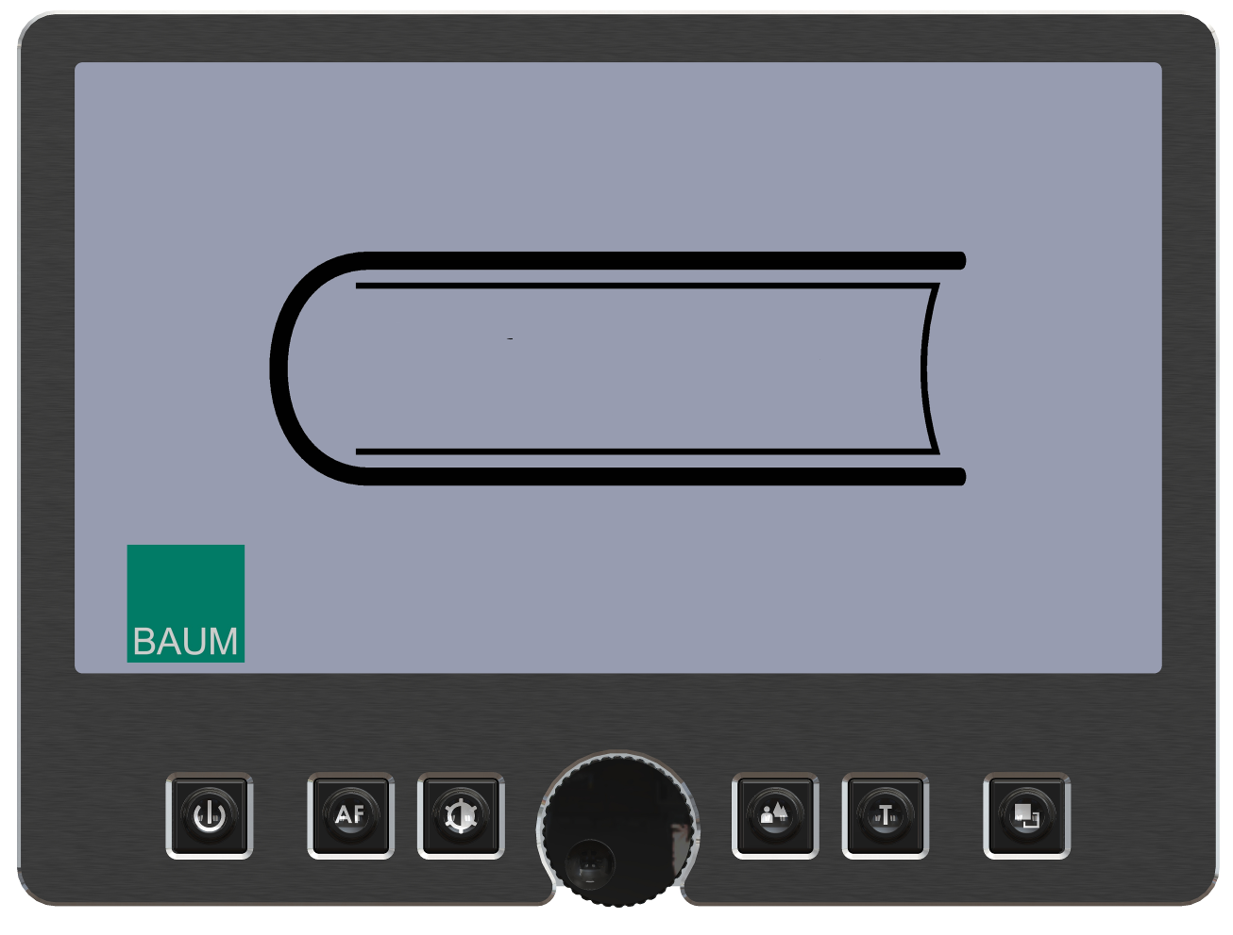

# VisioDesk Control panel buttons – quick reference

|  |  |
| --- | --- |
| Bedienteil2-1 | **Power**  Short press (until lights are on) will power up device.  Short press to show battery level.  Long press will switch off. |
| Bedienteil2-2-AF | **Auto Focus**  Toggles Auto Focus on and off.  Auto focus on has always a sharp image.  Auto Focus off is for taking handwritten notes. |
| bedienteil2-3-opti | **Image optimizer**  Selects one of five image quality optimizer settings for viewing critical documents with low contrast or bad print.  Long press turns on/off light. |
|  |  |
|  | **Zoom**  Turn the circular dial counter-clockwise to decrease magnification, and clockwise to increase magnification. |
| Bedienteil2-5-bild | **Picture**  For viewing pictures or reading documents in true colors. Also recommended for reading poor quality print and for writing.  If PC is connected, toggle between PC image and camera image. |
| bedienteil2-5-text | **Text - Reverse**  Use text mode for reading. Contrast is enhanced so reading is easier. Press again to toggle foreground and background colors. |
|  |  |
| bedienteil2-6-falschfarbe | **False Colors**  In text mode: Press to cycle through 7 false color modes. (Use Text button to reverse foreground and background). White on black is recommended for reading.  In picture mode: toggle white balance between warm reddish white, neutral white and cold bluish white. |

# Becoming Familiar With Your New VisioDesk

You have already learned how to position VisioDesk on your desk, and how to connect VisioDesk to the power adaptor. You can adjust height and tilt of the display to your preferred position so that you can comfortably view the screen.

Now, switch on VisioDesk and use it for the first time.

The **control panel** is located right below the screen. It consists of only six buttons and a circular dial.

The **power button** bedienteil-power is located in the lower left corner. A short press of this button will switch VisioDesk on. As soon as the lights turn on, you can release the power button. The display shows a start-up screen, after a few seconds VisioDesk shows a magnified image. The battery level is shown for a few seconds.

A short press on the power button bedienteil-power will show the battery level again at any time. The battery is full if the battery symbol is completely filled. A flashing on the battery symbol shows it is charging.

You can switch VisioDesk off by pressing the power button bedienteil-power for more than one second. This helps avoid accidentally switching off VisioDesk. Now, let’s practice switching the device on and off a couple of times, and then leave it switched on to proceed to the next step.

|  |  |
| --- | --- |
|  | Place a document on the base plate. We suggest something colored, such as a brochure or magazine with text and images.  You can align a document horizontally by moving it against the silver rim in the back of the base plate. |

Let’s try the other buttons on the control panel. We have already learned the power button, which you found in the lower left corner.

Direct your attention toward the lower middle part of the control panel. There you will find a circular dial with a ridged edge. You may also notice a small indented circle on the front face of the dial. This is the **zoom control dial,** 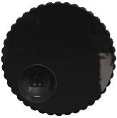which controls magnification. Turning this dial clockwise will increase magnification, while turning it counter clockwise will decrease magnification. Turn the zoom control counter clockwise to the start position to obtain minimum magnification now. The indented circle will be at the 7 o’clock position when the dial is at the start position.

The minimum zoom level is not primarily intended for reading; rather, it provides you with a better overview on the document structure. Thus you can easily find the position you want to view at higher magnifications.

Now, press the **picture button** . This button is located to the right of the zoom control dial. Pressing this button will set VisioDesk to true color.

The true colors are ideal for viewing images and also serves well for reading poor quality print, and for writing or filling in forms. It provides all natural colors in all shades.

Now, move the paper until you see one of the images of your document appear on the screen. If the image is too small, increase the magnification by turning the zoom control clockwise. If you get lost and do not know where you are on the document, decrease magnification, find your place on the page, and then increase magnification again.

**NOTE:** if you are using high levels of magnification, you may find it easier to increase magnification in increments, make adjustments to the placement of your document, and then repeat. If you move quickly from the smallest to the largest magnification, what was once in the middle of the screen will have disappeared.

Move the paper to a position where you see some text on the display. Now press the **text button** . The text button is located to the right of the picture button it is the second button to the right of the zoom control dial.

The image will be displayed in high contrast now and in two false colors only.

Press the Text button again to reverse the image. In this mode, letters are much clearer and brighter with higher contrast, whereas in true colors you see all colors and shades of grey.

You see the difference? Black on white and white on black or any other false colors in Text mode will show crisper characters in higher contrast, whereas the true color mode shows you real colors and all shades of grey.

You do not like the colors shown in text mode? No problem! Let us change them. You have a selection of seven false color combinations and with reversing foreground and background you will have 14 different color options. Try out by pressing the **false color button** . This is the rightmost button on the control panel. Each time you press it, the colors will change. After you went through all 7 options it will start over again. If you want to reverse foreground and background, press the text button.

The available false colors are black-white, black-yellow, black-cyan, black-green, black-magenta, blue-white and blue-yellow.

Select the colors you prefer with the false color button and press the text button for reversing foreground and background until you find the option you prefer.

In picture mode, the false color button has a different function. There you may change the white balance. Press this button to toggle between a warm reddish white, especially for viewing photos, a neutral white or a cold bluish white that is good for reading colored texts.

Now choose the setting you prefer for reading. Take all the time you need to find out the best setting for your needs. Most users prefer white characters on black background.

**Note:** VisioDesk remembers the last used color setting that you made before you turned it off.

Now that you have found your preferred settings, let us try to read some more complex examples with poor quality print. In most cases, the automatic contrast feature in VisioDesk will magnify your document and present it in high contrast with crisp characters. Sometimes however, the automatic contrast will not find the best setting. That may likely happen with documents where the print quality is poor, or with colored characters that are printed on a colored background. In these cases you may want to experiment with the **Image Optimiser** 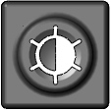button to find the best settings. This is the third button from the left, directly left to the zoom knob. The image optimiser button selects one of five levels of optimisation. So if you do not get a good quality representation on VisioBook’s display, simply press this button several times until you get the best result.

This button works in picture mode as well as in text mode.

**Note:** You will often find the previous setting was the best one, so the trick to get one step back is by pressing the button four more times.

## **Switch off light**

When reading glossy paper or backlit displays like such of mobile phones, then VisioBook’s light may cause reflections or blinding effects on the camera image. In such cases you should switch off the light by a long press on the image optimizer button . One more long press will switch the light back on again.

## **Autofocus**

VisioDesk has a permanent autofocus which is always active at power on. That means, no matter how thick a book or how curved a page might be, VisioDesk will always focus on the part displayed and thus always present a sharp image on the display. This feature is also helpful when reading text on a curved surface, such as a can or a medicine bottle. So this is the setting you usually will prefer.

However, sometimes you want to fill in forms or crossword puzzles or you want to paint your nails or view three-dimensional objects. This is where fixed focus comes into play.

First, let us find that button. The auto focus button  is the second button from the left. Press it to toggle auto focus on and off. On the screen “AF ON“ or “AF OFF” will be displayed for a few seconds respectively.

Let us test how this works. If you have already played with this button, press the Auto Focus button once or twice and check for “AF ON” being displayed to make sure, automatic focus is on. VisioBook will magnify the document on the base plate and display a sharp image. Put your hand on the document now. VisioBook will magnify your hand and you see the skin of your hand is focused now while the characters on your document are blurred. The same may happen when you want to fill in a form. Instead of showing sharp letters, VisioBook may focus on the back of your hand holding a pencil. If you remove your hand, the characters are sharp again.

So let us try the same with fixed focus now. Place a form on the base plate. If VisioBook does not show sharp characters, press the auto focus button. “AF ON“ will be displayed. Now that the characters are sharp, press the Auto Focus button again to switch it off. “AF OFF“ will be displayed. If you fill in the form with a pencil now, VisioBook will always stay in focus on the characters and not on your hand. Once finished, do not forget to turn auto focus on again by pressing the Auto Focus button.

## **Alternative set of false colors**

VisioBook comes with two sets of 7 false colors each. The standard set has very bright intense colors, with high contrast. This is appropriate for most users.

The standard colors are: black-white, black-yellow, black-cyan, black-green, black-magenta, blue-white and blue-yellow.

For special needs, there is a second set of softer colors with less contrast. This is especially helpful if you are sensitive to blinding effects from high intensity light.

The alternative colors are: black-white, black-ivory, black-soft yellow, black-soft peach, black-soft pink, blue-ivory, blue-white.

To switch between the two sets, press Picture button  and Text button  simultaneously while pressing the power button bedienteil-power on power on. VisioBook will remember this setting, so you only have to do this once.

# External connections of VisioDesk

VisioDesk provides three sockets to connect external devices. In the middle there is the USB 3 output, to the left a video input and to the right a video output. All three sockets are located at the rear of the display.

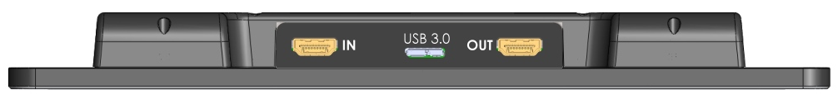

## **USB Output**

This micro USB 3.0 socket (labeled “USB”) is for connecting a PC. VisioBook will be recognized as a standard camera device by Windows XP, VISTA, 7, 8 and a MAC. No special drivers are required.

The video signal is full HD 1920 by 1080 pixels at a full frame rate of 60Hz. Smaller resolution are available for slower devices which cannot handle full HD video.

Use a standard program like Amcap or VLC player or Media player classic for Windows to view images transferred from VisioBook. You may also save still images and videos. A special video software is not part of VisioBook.

## **Video output**

This HDMI socket (labeled “OUT”) provides a DVI-D signal with a resolution of full HD 1920x1080 Pixels at a full framerate of 60Hz. It is for connecting an appropriate display with HDMI input or – by using an adaptor – DVI-D input. The monitor must support the above resolution. The image will be shown on the external display as well as on VisioDesk’s display.

## **Video input**

This HDMI socket is for connecting a PC or another video source with DVI-D signal in full HD 1920x1080 Pixel resolution at a full frame rate of 60Hz. The image will be shown on VisioBook’s display. (Copy protected video signals are not supported).

Use the Picture button to switch between camera image and external video source.

**You’re Ready!**

You have now learned all there is to know about using VisioDesk. We hope you will enjoy your new magnifier for many years to come.

# For your safety

**WARNING:** Failure to observe the following warnings may invalidate the guarantee and could cause damage of the device or serious injury.

Please check contents of package before you use the device. If parts are damaged or missing, contact BAUM Retec or your local dealer.

Please retain the shipping box so that you can safely pack the device in the unlikely event that it needs to be returned for service, etc. Improper packaging could void the product warranty. In case you need a new shipping box, BAUM Retec or your dealer can provide one for a small fee.

Please carefully read the user manual and safety instructions before you use the device for the first time.

* This device may only be used in a home or office environment.
* Do not place on an uneven surface, as the device may fall causing serious damage to the device and/or injury to you or another person.
* Follow the instructions on how to position the device, especially with respect to keeping proper spacing from the edge of the table surface; this will help prevent the device from tilting or falling.
* VisioDesk contains moving parts. Please take care when adjusting the display or moving the arms to fold the device. Injury may occur if fingers or clothing are caught in the operating mechanism. If you have difficulties in operating the unit safely, please seek advice from BAUM Retec or your local dealer.
* Connect the power adaptor to a grounded power outlet only.
* Do not use the device if you find any damage of the device itself, or any wires.
* If the device appears to be operating abnormally, or appears to be damaged in any way, please unplug from any power source, and contact BAUM Retec or your local dealer as soon as possible.
* If you smell smoke or an odor coming from the device, turn off the power immediately.
* Do not attempt to repair the device yourself. Opening or removal of housing may cause damage or injury, and will void the warranty.
* Do not allow sand or dust to come into contact with the device as this may lead to serious damage and could make repair impossible.
* Use the device with clean hands only.
* Do not use in locations where strong radio waves are emitted or where there is radiation. Try to maintain a distance of at least 12 inches (30 cm) from mobile phones.
* Only use original factory supplied accessories. Use of second source accessories may damage the device or cause malfunction or safety issues.
* Do not use a third-party power adaptor not made for this device. Only use the original power adaptor!
* Do not use the VisioDesk power adaptor with other devices.
* Keep liquids and food away from VisioDesk. It should only be fed electricity from time to time.
* Do not use or store the device in any of the following places as this may cause damage:
  + Inside cars parked with the windows closed in the hot sun.
  + In direct sunlight or close to heaters, radiators, etc.
  + Locations subject to severe vibration such as on top of a washing machine.
  + Locations subject to strong magnetism such as near loudspeakers.
  + Humid places (bath room), in water, or near water.
  + In rain or snow
  + Do not use or store below 32°F or above 104°F (0°C or above 40°C)
  + Humidity that is below 20% to above 80%
  + Avoid fast temperature changes
    - If you bring the device from a cold place into a warm room, humidity may condensate. Wait until the device is dry and at room temperature before use.
* Unplug from power source before cleaning.
* Wipe dust and dirt from the device with a soft cloth dampened with a diluted neutral detergent, then wipe dry with a cloth. Do not bring in contact with water.
* Do not insert objects into openings.
* Do not use device during thunderstorms. Unplug from any power outlet during thunderstorms.
  + We recommend use of a surge protector, which can be bought from your local electronics store, or possibly through your local dealer. Note that this does not provide a 100% protection from a voltage surge.
* Do not insert or remove the plug with wet hands.
* Do not heat in a microwave oven, place on a stove, or similar.
* Never disassemble, attempt to repair or modify VisioDesk yourself.
* If liquids or metal fragments should enter device, switch it off and remove the power cord immediately.
* Do not pull the plug out by the cable when removing the power plug.
* Do not throw, or allow the device to fall.
* Repairs may only be carried out by BAUM Retec service personnel or by service technicians authorized by BAUM Retec AG.

# Common problems and solutions

In the unlikely event that VisioDesk is not working properly, first try some of the solutions below in order to address the problem. If this does not help, please switch VisioDesk off, unplug the power cable from any power source, and contact our service department.

## **Display and light remain dark**

Please try to switch VisioDesk off and on again. If this does not help, make sure the power adaptor is connected to both VisioDesk and wall outlet and that wall outlet is live. You may want to connect another device to the wall outlet to check.

* Are all plugs seated properly in their sockets?
* Are you using the correct power adaptor?

## **Image is blurred**

Check if camera window is dirty. Turn the magnification control dial to the middle position.

Press Auto Focus button. It must show “AF ON“, else wise press again.

## **Document cannot be read**

Turn magnification dial clockwise to make sure the problem is not magnification set to a level that is too low. Try changing the **False Colors - Picture** button to view your document in a different setting.

Try different settings of image optimizer button.

## **Letters are flickering**

Increase the magnification by turning the magnification control clockwise.

Try different settings of the **False Colors - Picture** button.

Try different settings of the Image optimizer button.

**If your issue is not listed here, please contact us:**

|  |  |
| --- | --- |
| **USA**  BAUM Retec, Inc.  13 Branch Street, Suite 205  Methuen, MA 01844, USA  Tel: +1 855-620-7985  Email: [support@baumusa.com](mailto:support@baumusa.com) | **World Headquarters**  BAUM Retec AG - Service,  In der Au 22  D-69257 Wiesenbach  Germany  Tel: +49 6223 4909-0  E-Mail: [service@baum.de](mailto:service@baum.de) |

**Compliances**

Please refer to the end of this user manual for compliance declarations.

Electronic assistive devices need special precautions regarding Electro Magnetic Compatibility (EMC). It must be installed and serviced according to the EMC guidelines.

**WARNING:** Use of accessories, transducers and cables other than those specified and sold with the device by the manufacturer as replacement parts may result in increase of emissions or decrease of immunity of the device.

# Environmentally friendly disposal according to EC-Directive 2002/96/EG

|  |  |
| --- | --- |
|  | The symbol (crossed garbage can), which is also attached to the device, states that this device and its accessories, once come to the end of its lifetime, should not be regarded as household waste. An environmentally friendly way of final disposal is compulsory. |

This device contains electronic components. In order to avoid risks or dangers for the environment through non-professional waste disposal, the disposal of this device and its accessories must correspond to the valid EC-Directives or other local regulations. Please check your local regulations for proper disposing of this device or consult your local distributor.

# Warranty

BAUM Retec AG warrants the device, effective from the date of delivery, to be free of any defects in material and workmanship. Warranty is not transferable and does not apply to groups, multi users or agencies. This device has been designed for the individual purchaser to be used in home or office environments. BAUM Retec AG reserves the right to repair or replace with a similar or better product. In no event shall BAUM Retec AG or its distributors be liable for indirect or consequential damages. The original users’ remedies are limited to replacement of devices modules/parts. This warranty is valid only when service is done in the country of original purchase and with intact warranty seals. For additional warranty claims or service during or after warranty period, please refer to your distributor. BAUM Retec AG does not take responsibility for use of this device other than described in this manual.

* Warranty on new devices is 24 months.
* Warranty on used or refurbished devices is 12 months.
* Warranty on Consumable parts (Batteries, Braille Pins, Data carriers etc.) is 6 months.
* Warranty on repairs and spare parts is 12 months.

All defects caused by improper use or users fault are not covered by this warranty.

Ownership of parts replaced during repair become the property of BAUM Retec AG, and will not be returned to the customer.

In the event device repair is required, the VisioDesk must be properly packed into its original shipping box or service box.

Costs for packing, shipping and insurance are not covered by BAUM Retec AG.

# Defects and Repair

What to do if VisioDesk stops working properly:

* Did you check all settings and connections according to the manual?
* Did you remove the protective plastic film from the camera lens?
* Is VisioDesk plugged into a live power outlet?

If VisioDesk is not working, please disconnect from any power outlet, discontinue using the device, and contact BAUM Retec or your authorized BAUM Retec dealer.

To contact BAUM Retec please refer to the contact information below. BAUM Retec, Inc. is your contact for any VisioDesk purchased/sold in the USA. For all other customers, please contact BAUM Retec AG in Germany.

We will help you first troubleshoot your VisioDesk. If we determine that your device needs to be returned to us for repair, you will need to pack the VisioDesk in its original packaging. If someone is assisting you, please show them this manual so that they can refer to the proper instructions for folding and packing VisioDesk, which can be found further down this page.

**Service Contact Information:**

|  |  |
| --- | --- |
| **USA**  BAUM Retec, Inc.  13 Branch Street, Suite 205  Methuen, MA 01844, USA  Tel: (855) 620-7985  Email: [support@baumusa.com](mailto:support@baumusa.com) | **World Headquarters**  BAUM Retec AG - Service,  In der Au 22  D-69257 Wiesenbach  Germany  Tel.: +49 6223 4909-0  E-Mail: [service@baum.de](mailto:service@baum.de) |

# Service box

For shipping VisioDesk in the service box, proceed as follows:

* Switch off VisioDesk
* Unplug from any power source
* Put display in upright position, swing it down and back against arms. Then fold arms down to base.
* Put VisioDesk into transport bag and put transport bag in service box.
* Put 4 corrugated cardboard covers around transport bag and do not forget power supply and cable.
* Close the box.

# 

# Technical Specifications

* Foldable HD CCTV with full HD1920x1080p/60Hz resolution
* 4 camera positions: direct down view to base, pivoted down view to front base with auto distortion correction, Far view, and Mirror view.
* Automatic distortion correction.
* Screen size: Approximately 15.6“ (39,3 cm) 16:9 widescreen with LED backlight
* Full color mode
* Two sets of 7 false color settings each with enhanced contrast and reverse image giving 14 combinations each.  
  Standard set: (black-white, black-yellow, black-cyan, black-green, black-magenta, blue-white and blue-yellow)  
  Alternative set: black-white, black-ivory, black-soft yellow, black-soft peach, black-soft pink, blue-ivory, blue-white.
* Autofocus
* Fix focus for hand writing
* Automatic exposure
* Magnification range: approximately 1.7x to 35x
* Camera distance to base 11.4” (290mm)
* Ports: USB 3 out (Micro USB 3.0) (Standard camera device), Input for external video source like PC’s DVI-D Signal on HDMI plug (Resolution 1920x1080p60Hz), Video out DVI-D on HDMI plug (Resolution 1920x1080p/60Hz)
* Light weight: 10.5 lbs (4.8kg)
* Dimensions:
  + In operation/unfolded: 14.7” (375mm) wide x 14.7” (375mm) deep x 13,7”- 23,6 (350-600mm) high depending on display position
  + Folded: 14.7” (375mm) wide by 14.7” (375mm) deep by 2.3” (60mm) high
* Power supply 100-240V AC 50/60 Hz AC-Adaptor 19 V / 60 W
* Rechargeable Battery
* Power consumption in operation: < 15 W
* Battery Life (Fully charged): 6 hours of continuous operation

|  |  |
| --- | --- |
| **Manufacturer:**  BAUM Systeme GmbH In der Au 22 D-69257 Wiesenbach Germany  **Sales and Support:** |  |
| **USA**  **BAUM Retec, Inc.**  **13 Branch Street**  **Methuen, MA 01844 USA**  **Phone: +1 (855) 620-7985**  **Fax: +1 (978) 420-4401**  **Email:** [**info@baumusa.com**](mailto:info@baumusa.com)  **Web:** [**www.baumusa.com**](http://www.baumusa.com) | **Germany/International**  **BAUM Retec AG**  **In der Au 22**  **D-69257 Wiesenbach Germany**  **Phone: +49 6223 4909-0**  **Fax: +49 6223 4909-399 Email:** [**info@baum.de**](mailto:info@baum.de) **Web:** [**www.baum.de**](http://www.baum.de) |

**The following statement regarding information for the Re-use of VisioDesk applies to end users in Germany only.**

## **Product description:**

Stationary opto-electronic CCTV magnifying device for magnifying texts and images. The reading materials are being viewed and magnified by the camera and directly shown on the integrated monitor.

Image-enlarging video system code 22 03 18 according to ISO 9999:2011.

## **Specific purpose:**

CCTV magnifiers are medical devices used to assist reading black print material. Visually impaired people use these devices to compensate their partial loss of vision or eye-illnesses.

## **Product life time:**

7 years from manufacturing date, provided that the recommended service and maintenance intervals have been complied with.

## **Re-use / Installation and Maintenance:**

The device may only be repaired, technically refurbished and reconditioned by BAUM service personnel or by service technicians authorized by BAUM Retec AG. Further use or re-use is only allowed after a thorough technical cleaning and disinfecting in combination with a safety check.

## **Safety checks (§6 MP-BetreibV):**

Safety checks must be conducted by BAUM Retec AG, or by an organization authorized by BAUM Retec AG to perform such safety checks.

BAUM Retec AG does not stipulate certain intervals or deadlines for safety checks. The statements made in §6 Medizinprodukte-Betreiberverordnung regarding intervals and deadlines are however recommended at least every two years).

An assessment of the safety condition of a device is made during a safety check according to German standard DIN VDE 0701-0702.

## **Special advice for transport and storage:**

For safety reasons it is necessary to store and transport this device either in its original packaging or in a designated service box. This device must be stored in its original packaging or in the designated service box and in a dry and closed storage space. The following conditions for storage and transport must be respected:

• Temperature range: 32°F to 122°F (0°C to +50°C)

• Relative air humidity: 20 % to 80 %

## **Power cable:**

Please use only the original power cable that has been supplied by BAUM Retec AG.

**WARNING:** Using accessories other than those specified and sold with the device by the manufacturer as replacement parts may result in increase of emissions or decrease of immunity of the device.

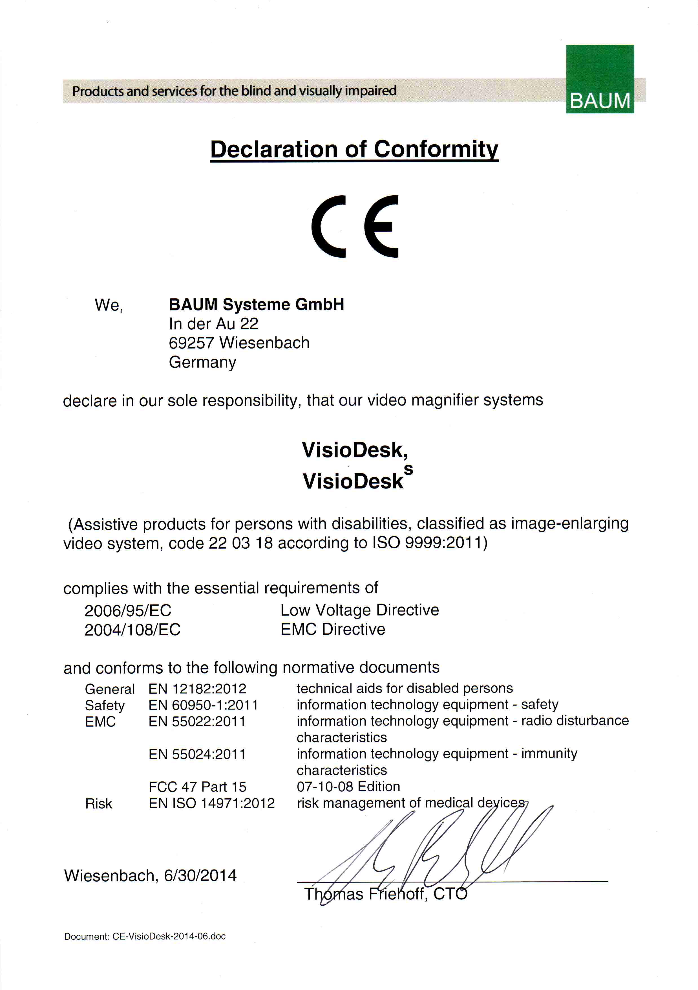

# Product Identity Sheet VisioDesk

**Type:**

🞎 VisioDesk

🞎 VisioDesk

**Serial Number:**

**Manufacturer:** BAUM Systeme GmbH, D-69257 Wiesenbach, Germany.

**Supplier:**

**Year of purchase:**

**User\*: 1.**

**2.**

**3.**

**4.**

**5.**

**End test:**

**Delivery date / Shipping date: ­­­­­­­­­­­­­­­­­­­­­­**

**Power supply**: 100-240 V AC 50/60 Hz 19 V / 60 W

**Power consumption:** approx. 15 W

**Display size:** TFT-Monitor 15.6” (approximately 40cm) wide

**Installed by:**

**First safety check\*\*:**

\* In case of another Customer or user, the next user must be mentioned on next line.

\*\* In case of re-using a device a new safety check is required!

**Sales and Support:**

BAUM Retec AG

In der Au 22

D-69257 Wiesenbach  
Germany

Phone: +49 (0) 6223 / 4909-0

Fax: +49 (0) 6223 / 4909-399

E-Mail: info@baum.de

Web: [www.baum.de](http://www.baum.de)

**Manufacturer:**

BAUM Systeme GmbH

In der Au 22

D-69257 Wiesenbach  
Germany

Please be advised that this manual may contain errors, and is therefore subject to being changed or updated without prior notice.